Day 8: 29 September 2024

Web Service: Giving the service for web application when both application running using different technologies.

Spring boot

Amazon -🡪 Payment --🡪

Paytm Java

Paypal python

Gpay asp.net

PhonePay php

Credit or Debit card node js

Web Service can be platform independent, language independent as well as browser independent.

Java (Req) ----------------------------🡪

App1 XML/JSON App2

Java Python

🡨---Python (Res)

XML : eXtensible Markup language

JSON : Java Script Object Notation

Employee emp = new Employee(100,”Ravi”,12000);

Xml format of this object is

<Employee>

<Id>100</Id>

<Name>Ravi</Name>

<Salary>12000</Salary>

</Employee>

JSON format of Employee

{“id”:100,”name”:”Ravi”,”salary”:12000}

To convert our data in xml or json we need Web Service.

2 types

1. SOAP base Web Service : Simple Object Access Protocol. SOAP Web Service base upon SOA (Service Oriented Architecture). In SOAP web Service we need consume as well as produce the data only in the form of XML.
2. Rest Full Web Service : Representation State Transfer. Using Rest full web service we expose our resources like Servlet or JSP or spring controller as web service in any format base upon client requirement like xml, json, plain text, html or any media type.

In Java if we want to create SOAP Web Service we need to use

JAX_WS (Java API for XML Web Service)

In Java if we want to create Rest full web service we need to use

JAX_RS (Java API for XML Rest Full Web Service)

JAX_RS implementation can be provided by

Jersey tool

Spring framework as well as Spring boot.

If we want to make our Servlet or JSP program we JAX_RS ie Rest full web service we are using Jersey tool.

If our spring boot controller is @Controller then view must be JSP or thymeleaf or html. If our controller is @Controller then view tightly coupled with controller.

If our spring boot controller is @Restcontroller then view can be any other technologies like asp.net, php, python, angular, react js or any rest client. But out controller is @RestControlelr then view can any technologies they are loosely coupled.

According to Rest API we need to use Http methods.

Get method : this method is use to get the resources like employee details, consumer details , product details like select query.

Post method : this method is use to create the resource like employee or customer like insert query

Put method : this method is use to update the resource like update employee salary using id, update customer phone number using cid like update query.

Delete method this method is use to delete the resource like delete employee details using id like delete query

Spring-boot-restapi

Starter -🡪Web web application

Starter 🡪 Jpa for ORM as well as Spring JPA Data

Dependency 🡪 MySQL

Starter 🡪Dev tool (if we do any changes in project automatically refresh the application).

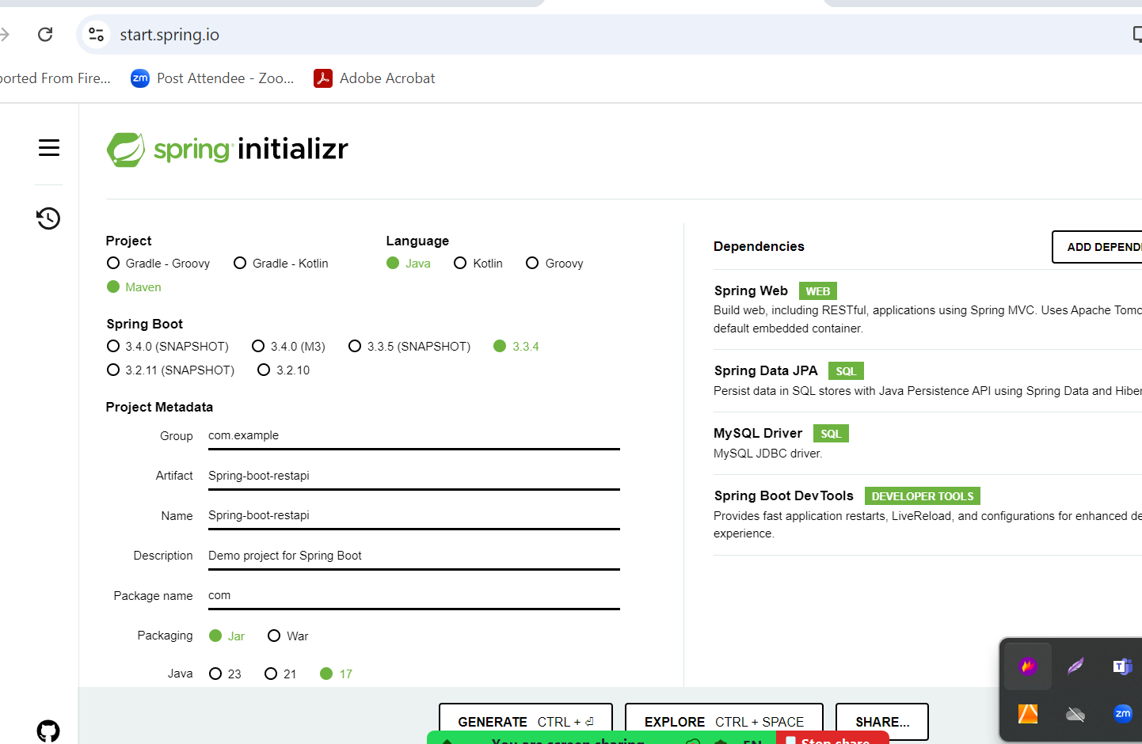

We can test only get method end point or api through browser.

If we need to test remaining end point like post, put, delete we need to use tools

Postman

In non window(terminal) or window using GIT (we can use CURL command base we can test).

1. Get : Get all product details in json format.
2. Get : Search particular product base upon pid(PK).
3. Path param : URL/value
4. Query param : URL?key=value (form with get method internally use query param technique).